Write a program to compute subtraction of two complex numbers using operator overloading.
44).

#include <iostream>
using namespace std;

class com {
float real, imag;
public:
com(float r = 0, float i = 0) {
real = r;
imag = i;
}
void getData() {
cout << "Enter real part: ";
cin >> real;
cout << "Enter imaginary part: ";
cin >> imag;
}
com operator - (com c) {
return com(real - c.real, imag - c.imag);
}
void display() {
cout << real;
if (imag >= 0)
cout << " + " << imag << "i";
else
cout << " - " << -imag << "i";
}
};

int main() {
com c1, c2, sub;
cout << "Enter first complex number:\n";
c1.getData();

cout << "\nEnter second complex number:\n";
c2.getData();

sub = c1 - c2;
cout << "\nFirst Complex Number: ";

c1.display();
cout << "\nSecond Complex Number: ";
c2.display();
cout << "\nSubtraction: ";
sub.display();

return 0;
}
- Output:
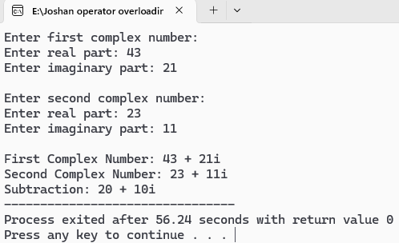

Write a program to compute addition of two complex numbers using operator overloading.
45).

#include <iostream>
using namespace std;

class com {
float real, imag;
public:
com(float r = 0, float i = 0) {
real = r;
imag = i;
}

void getData() {
cout << "Enter real part: ";
cin >> real;
cout << "Enter imaginary part: ";
cin >> imag;
}

com operator + (com c) {
return com(real + c.real, imag + c.imag);
}

void display() {
cout << real;
if (imag >= 0)
cout << " + " << imag << "i";
else
cout << " - " << -imag << "i";
}
};

int main() {
com c1, c2, sum;

cout << "Enter first complex number:\n";
c1.getData();

cout << "\nEnter second complex number:\n";
c2.getData();

sum = c1 + c2;
cout << "\nFirst Complex Number: ";
c1.display();
cout << "\nSecond Complex Number: ";
c2.display();
cout << "\nSum: ";
sum.display();

return 0;
}
- Output:
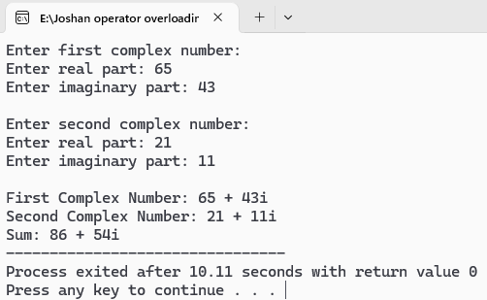

WAP to multiply two objects.
46).

#include <iostream>
using namespace std;
class Number {
float value;
public:
Number(float v = 0) {
value = v;
}
void getData() {
cout << "Enter value: ";
cin >> value;
}
Number operator * (Number n) {
return Number(value * n.value);
}
void display() {
cout << value;
}
};
int main() {
Number n1, n2, product;
cout << "Enter first number:\n";
n1.getData();
cout << "\nEnter second number:\n";
n2.getData();
product = n1 * n2;
cout << "\nProduct: ";
product.display();
return 0;
}
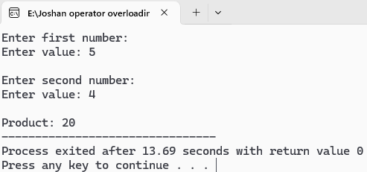
- Output:

WAP to illustrate modulo and normal division of objects using operator overloading.
47).

#include <iostream>
using namespace std;
class Number {
int value;
public:
Number(int v = 0) {
value = v;
}
void getData() {
cout << "Enter value: ";
cin >> value;
}
Number operator / (Number n) {
if (n.value == 0) {
cout << "Error: Division by zero!" << endl;
return Number(0);
}
return Number(value / n.value);
}
Number operator % (Number n) {
if (n.value == 0) {
cout << "Error: Modulo by zero!" << endl;
return Number(0);
}
return Number(value % n.value);
}

void display() {
cout << value;
}
};
int main() {
Number n1, n2, divResult, modResult;
cout << "Enter first number:\n";
n1.getData();
cout << "\nEnter second number:\n";
n2.getData();
divResult = n1 / n2;
modResult = n1 % n2;

cout << "\nDivision result: ";
divResult.display();
cout << "\nModulo result: ";
modResult.display();

return 0;
}
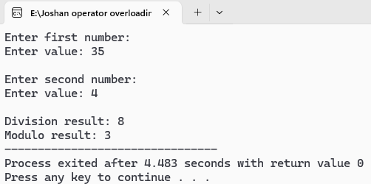
- Output:

Write a program that takes two amounts (can be in RS and PS) as input and decide which one is less.
48).

#include <iostream>
using namespace std;
class Amount {
int rs, ps;
public:
void getData() {
cout << "Enter rupees: ";
cin >> rs;
cout << "Enter paise: ";
cin >> ps;
}
bool operator < (Amount a) {
int total1 = rs * 100 + ps;
int total2 = a.rs * 100 + a.ps;
return total1 < total2;
}
void display() {
cout << rs << " Rs " << ps << " Ps";
}
};
int main() {
Amount a1, a2;
cout << "Enter first amount:\n";
a1.getData();
cout << "\nEnter second amount:\n";
a2.getData();
cout << "\nSmaller amount is: ";
if (a1 < a2)
a1.display();
else if (a2 < a1)
a2.display();
else
cout << "Both amounts are equal";
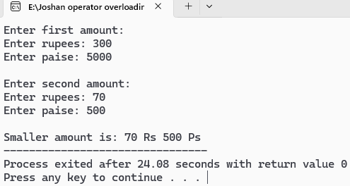
return 0;
}
- Output:

Write a program to compare the two distances taken as input in the program and decide which one is greater than other.
49).

#include <iostream>
using namespace std;

class Distance {
int feet, inches;
public:
void getData() {
cout << "Enter feet: ";
cin >> feet;
cout << "Enter inches: ";
cin >> inches;
}

bool operator > (Distance d) {
int totalInches1 = feet * 12 + inches;
int totalInches2 = d.feet * 12 + d.inches;
return totalInches1 > totalInches2;
}

void display() {
cout << feet << " feet " << inches << " inches";
}
};

int main() {
Distance d1, d2;
cout << "Enter first distance:\n";
d1.getData();
cout << "\nEnter second distance:\n";
d2.getData();
cout << "\nGreater distance is: ";
if (d1 > d2)
d1.display();
else if (d2 > d1)
d2.display();

else
cout << "Both distances are equal";

return 0;
}
- Output:
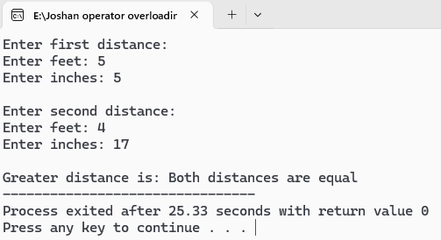
Design a class Matrix of dimension 3x3. overload + operator to find sum of two matrices.
50).

#include <iostream>
using namespace std;

class Matrix {
int mat[3][3];
public:
void getData() {
cout << "Enter of 3x3 matrix:\n";
for (int i = 0; i < 3; i++)
for (int j = 0; j < 3; j++)
cin >> mat[i][j];
}
Matrix operator + (Matrix m) {
Matrix temp;
for (int i = 0; i < 3; i++)
for (int j = 0; j < 3; j++)
temp.mat[i][j] = mat[i][j] + m.mat[i][j];
return temp;
}
void display() {
cout << "Matrix:\n";
for (int i = 0; i < 3; i++) {
for (int j = 0; j < 3; j++)
cout << mat[i][j] << " ";
cout << endl;
}
}
};

int main() {
Matrix m1, m2, sum;
cout << "Enter first matrix:\n";
m1.getData();
cout << "\nEnter second matrix:\n";
m2.getData();
sum = m1 + m2;
cout << "\nSum of matrices:\n";
sum.display();
return 0;
}

- Output:
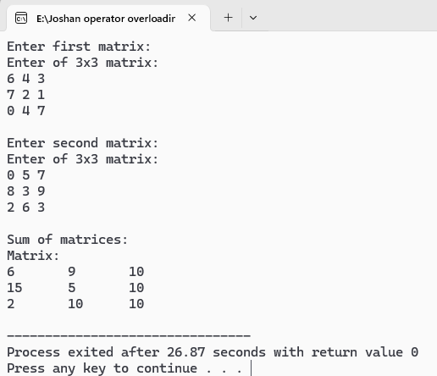

Write a program that decreases an integer value by 1 by overloading -- operator.
51).

#include <iostream>
using namespace std;

class Number {
int value;
public:
Number(int v = 0) {
value = v;
}
void getData() {
cout << "Enter value: ";
cin >> value;
}
// Overload prefix -- operator
void operator--() {
--value;
}
void display() {
cout << "Value: " << value << endl;
}
};
int main() {
Number n;
n.getData();
--n; // Decrement using overloaded --
cout << "After decrement: ";
n.display();
return 0;
}
- Output:
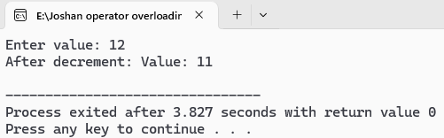
Write a program that increases an integer value by 1 by overloading ++ operator.
52).

#include <iostream>
using namespace std;

class Number {
int value;
public:
Number(int v = 0) {
value = v;
}
void getData() {
cout << "Enter value: ";
cin >> value;
}
// Overload prefix ++ operator
void operator++() {
++value;
}
void display() {
cout << "Value: " << value << endl;
}
};
int main() {
Number n;
n.getData();
++n;
cout << "After increment: "<<endl;
n.display();
return 0;
}
- Output:
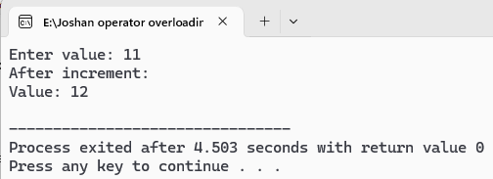

Write a program to find next element of Fibonacci series by overloading ++ operator.
53).

#include <iostream>
using namespace std;
class Fibonacci {
int x, y;
public:
Fibonacci() {
x = 0;
y = 1;
}
void operator++() {
int next = x + y;
x = y;
y = next;
}
void display() {
cout << y << " ";
}
};
int main() {
Fibonacci fib;
int n;
cout << "How many Fibonacci numbers to generate? ";
cin >> n;
cout << "Fibonacci series: ";
for (int i = 0; i < n; i++) {
++fib;
fib.display();
}
cout << endl;
return 0;
}
- Output:
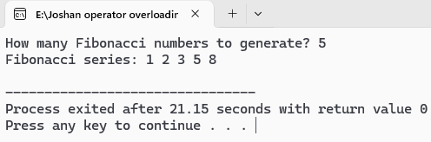

Write a program to convert kilogram into gram using user defined to user defined data conversion. (1kg = 100gm).
54).

#include <iostream>
using namespace std;

class Kilogram {
float kg;
public:
Kilogram(float k = 0) {
kg = k;
}
void getData() {
cout << "Enter weight in kilograms: ";
cin >> kg;
}
float getKg() {
return kg;
}
};
class Gram {
float gm;
public:
Gram() {
gm = 0;
}
void display() {
cout << "Weight in grams: " << gm << " gm" << endl;
}
Gram(Kilogram k) {
gm = k.getKg() * 1000;
}
};
int main() {
Kilogram k;
Gram g;
k.getData();
g = k;
g.display();
return 0;
}

- Output:
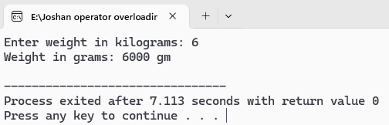

Write a program to convert an object of dollar class to object of rupees class. Assume that dollar class has data members dol and cent an rupees class have data members rs and paisa.
55).

#include <iostream>
using namespace std;

class Rupees;
class Dollar {
int dol, cent;
public:
Dollar(int d = 0, int c = 0) {
dol = d;
cent = c;
}
void getData() {
cout << "Enter dollars: ";
cin >> dol;
cout << "Enter cents: ";
cin >> cent;
}
int totalCents() const {
return dol * 100 + cent;
}
operator Rupees();
};
class Rupees {
int rs, paisa;
public:
Rupees(int r = 0, int p = 0) {
rs = r;
paisa = p;
}
void display() {
cout << "Equivalent Rupees: Rs " << rs << " and " << paisa << " Paisa\n";
}
};
Dollar::operator Rupees() {
int totalCents = dol * 100 + cent;
int totalPaisa = totalCents * 130;

int r = totalPaisa / 100;
int p = totalPaisa % 100;
return Rupees(r, p);
}
int main() {
Dollar d;
d.getData();
Rupees r = d;
r.display();
return 0;
}
- Output:
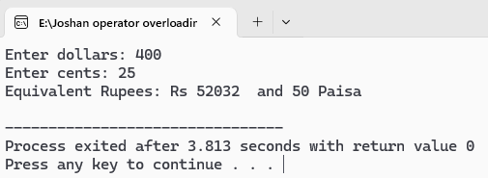

Write a program to convert object from class that represents temperature in Celsius scale to object of a class that represents it in Fahrenheit scale.
56).

#include <iostream>
using namespace std;

class Fahrenheit;
class Celsius {
float celsius;
public:
Celsius(float c = 0) {
celsius = c;
}
void getData() {
cout << "Enter temperature in Celsius: ";
cin >> celsius;
}
float getCelsius() const {
return celsius;
}
operator Fahrenheit();
};
class Fahrenheit {
float fahrenheit;
public:
Fahrenheit(float f = 0) {
fahrenheit = f;
}
void display() {
cout << "Temperature in Fahrenheit: " << fahrenheit << " F\n";
}
};
Celsius::operator Fahrenheit() {
float f = (celsius * 9 / 5) + 32;
return Fahrenheit(f);
}

int main() {
Celsius c;
c.getData();
Fahrenheit f = c;
f.display();
return 0;
}
- Output:
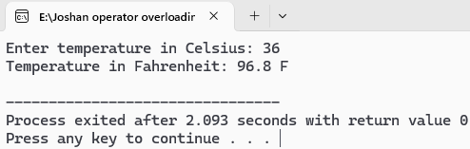

Write a program to convert object from a class that represents weight of gold in Nepal tola, to object of a class that represents international gold measurement of weight in gram scale( 1 tola 11.664 gram).
57).

#include <iostream>
using namespace std;

class Gram;

class Tola {
float tola;
public:
Tola(float t = 0) {
tola = t;
}
void getData() {
cout << "Enter weight in Nepali tola: ";
cin >> tola;
}
float getTola() const {
return tola;
}
operator Gram();
};
class Gram {
float gram;

public:
Gram(float g = 0) {
gram = g;
}

void display() {
cout << "Weight in grams: " << gram << " g\n";
}
};

Tola::operator Gram() {
float g = tola * 11.664;
return Gram(g);
}

int main()
{
Tola t;
t.getData();
Gram g = t;
g.display();

return 0;
}
- Output:
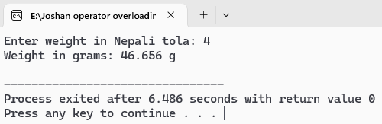

WAP to add two objects by overloading + operator using friend function.
58).

#include <iostream>
using namespace std;
class Number {
int value;
public:
Number(int v = 0) {
value = v;
}
void getData() {
cout << "Enter value: ";
cin >> value;
}
void display() {
cout << "Value: " << value << endl;
}
friend Number operator + (const Number &n1, const Number &n2);
};
Number operator + (const Number &n1, const Number &n2) {
return Number(n1.value + n2.value);
}
int main() {
Number n1, n2, sum;
cout << "Enter first number:\n";
n1.getData();
cout << "\nEnter second number:\n";
n2.getData();
sum = n1 + n2;
cout << "\nSum: ";
sum.display();
return 0;
}
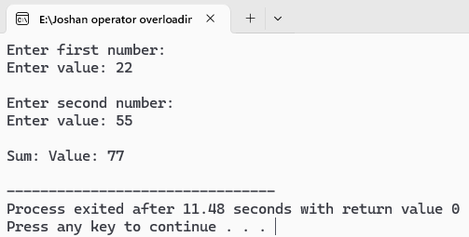
- Output:

WAP to increase value of count by overloading ++ operator using friend function.
59).

#include <iostream>
using namespace std;

class Counter {
int count;
public:
Counter(int c = 0) {
count = c;
}
void display() {
cout << "Count: " << count << endl;
}
friend void operator++(Counter &c);
};
void operator++(Counter &c) {
c.count++;
}
int main() {
Counter c;
c.display();
++c;
cout << "After increment: "<<endl;
c.display();
return 0;
}
- Output:
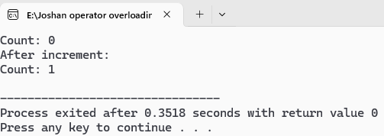

Create a base class animal with virtual function makesound(). Derive various classes (Dog , cat, bird) and Implement their specific to demonstrate calling makesound() using pointer of animal polymorphically.
60).

#include <iostream>
using namespace std;

class Animal {
public:
virtual void makeSound() {
cout << "Some generic animal sound\n";
}
virtual ~Animal() {} // Virtual destructor
};
class Dog : public Animal {
public:
void makeSound() override {
cout << "Dog says: Woof Woof\n";
}
};
class Cat : public Animal {
public:
void makeSound() override {
cout << "Cat says: Meow Meow\n";
}
};
class Bird : public Animal {
public:
void makeSound() override {
cout << "Bird says: Chirp Chirp\n";
}
};
int main() {
Animal* ptr;
Dog d;
Cat c;
Bird b;

ptr = &d;
ptr->makeSound();
ptr = &c;
ptr->makeSound();
ptr = &b;
ptr->makeSound();
return 0;
}
- Output:
